What the Future Development Strategy will address
The Future Development Strategy sets out the big picture vision for how and where we should grow over the next 30 years to achieve the best outcomes for Tāmaki Makaurau.
A changing environment
There has been a lot of change recently. Central government introduced legislation for more housing intensification across the city.
The effects of climate change are being felt more frequently, as seen by the Auckland Anniversary floods and Cyclone Gabrielle.
Addressing climate change
We also have a commitment to halve our greenhouse gas emissions by 2030 and reach net zero emissions by 2050 as part of
Te Tāruke-ā-Tāwhiri: Auckland's Climate Plan

2020(External link).
The way we grow and develop should improve the environment, avoid hazards and help address the impacts of climate change.
Focusing growth
This changing context means we need to update our strategy for how the city grows in the future.
There are many ways cities can grow. We propose that most new housing and business development be in the existing city near town centres, good public transport services and jobs, rather than spread out across the region.
Focusing growth in our existing urban areas, rather than more growth on the edges, results in improvements to the environment, the economy, and people’s wellbeing.
We will continue to invest in greenfield land currently under development to ensure they are successful and well-functioning.
We are proposing a small reduction in growth at the edge of the city for areas where we have identified significant natural hazard risks.
In some other areas on the city’s edge we are proposing to delay development until we can afford to provide the large-scale infrastructure needed to connect these areas to the wider network.
Some areas are proposed for further investigation to better understand hazard risks, the relationship between existing and future land uses and the likely levels of vehicle trips and CO2 emissions that would be generated.
What we want your feedback on
We want your feedback on our approach to how and where Auckland should grow and change.
Focusing growth
Denser, more compact cities result in improvements to the environment, the economy, and people’s wellbeing.
Auckland’s urban area is made up of neighbourhoods, town centres and business areas that are interconnected and that support where most Aucklanders live, work and spend their leisure time.
We propose that most housing and business growth will be focused within existing urban areas and that this growth be more intensive. This means less growth in greenfield areas at Auckland’s edges. What greenfield growth there is will be phased over 30 years and longer.
What do you think of our approach to focus most of Auckland's growth in existing urban areas?
Tell us why :
1. Agree
2. Disagree
3. Other
4. I don’t know

1. Greenfield developments allow planned integration of services and transportso deliver a better result than random development in constrained suburban areas.
There are many good examples of greenfield developments over the recent years including Stonefields centrally, Hobsonville Point in the west, Addison The Avenues (Takanini) in the south and Millwater in the north. These developments were able to be well planned with new infrastructure including schools, parks, commercial/retail areas and transport options appropriate for the population density planned. In a post-build study of Addison completed for Council in 2019 a key discussion point was the importance of integrated land use and infrastructure planning. The two post-build failings cited in the review were that the planned train station and the planned commercial development were not completed.
The greenfield approach looks to take away from the congestion that plagues our central city suburbs and create new planned communities with local services, transport hubs, excellent electric train and/or fast electric bus routes and local business and commercial zones creating local jobs, so we see it as a good future planning strategy, if delivered as planned.
2. Allowing intensification across all city suburbs results in scattered intensification causing severely compromised infrastructure and negative property and infrastructure impacts.
Adopting a scattered approach to density housing (as currently suggested with Plan Change 78 which zones most of Auckland suburban areas MHU) makes it cost prohibitive and logistically impossible to deliver the supporting infrastructure and services needed for the safe, healthy and climate change proof growth of Auckland.
Scattered intensification eliminates the option for integrated planning and will result in reactionary infrastructure projects to mitigate the issues caused by intensification in older built out areas. It would be strategically better to plan development into more tightly defined areas where an integrated plan can deliver expanded commercial, transport and infrastructure services to support the intensification.
3. Higher costs for infrastructure projects in built up areas than in greenfield areas
We need look no further than at the current state of our existing dated water pipes in our older suburbsfor infrastructure that is not coping with recentlevels of infill housing. There is significantly higher cost in laying new pipes in built up areas than in greenfield areas. Intensifying built out suburbs requires more schools, parks, transport and commercial developments to service the increased population. Failure to provide these will result in greater emissions and traffic congestion. It is so much more difficult to implement this new infrastructure where the land is already built out. It would take significant land purchases at ratepayer cost to provide the additional schools and parks which would be required to result in improvements to the environment, the economy, and people’s wellbeing in existing built-up areas.
4. An Auckland for all
Denser city living is not for all Aucklanders. While we see it as appropriate to create some well-planned areas of much greater intensification, where existing infrastructure and available land allows, it is equally important to maintain lower density areas to provide variety and options to meet all Aucklander’s needs.
5. Auckland’s topography and isthmus makes it prone to climate threats, supporting targeted and researched areas designated for growth, both within current urban and greenfield sites.
With the abundance of flood plains, natural streams, and land prone to coastal inundation, targeted and researched areas that will withstand climate change should become the growth areas of our city. Not all will be able to be accommodated in the current city’s boundary. Future proofing of our critical infrastructure and transport links is vital to ensure a well-functioning infrastructure system within the parameters of the projected climate change impacts.
6. Highrise and higher density zoning, with supporting community and commercial services, to be expanded along railway routes and rapid bus lanes.
The Climate Change Commission states, “Transport makes up an increasingly large share of our overall emissions and is the single highest contributor in Auckland”. Intensification along arterial roads will increase traffic congestion. Zoned intensification must be integrated with well-planned electric public transport options. Immediate and medium-term intensification should be targeted to current and future designated railway routes and rapid transit lane enabled neighbourhoods, where higher density developed areas are serviced with the vital transport infrastructure to support the population increase, without driving up emissions.
Identification and acquisition of land corridors required for future electric rail and bus networks needs to be planned and budgeted for now. Auckland Council’s growth strategy needs to be closely integrated with a future strategic plan for Auckland Transport.
Accessible local centres
When people have easy access to workplaces, services, facilities and shops, communities become more resilient and connected. It also helps to reduce travel time, emissions and lower household transport costs.
We propose focusing housing and business development near local centres where most people’s daily needs are easy to access by walking, cycling and public transport.
What do you think of our approach to focus development near local centres?

Tell us why :
1. Agree
2. Disagree
3. Other
4. I don’t know

1. Yes to town centres, but local centres only by exception.
We agree with regards to town centres but local centres need a detailed review. Local centres are often small and provide a limited variety of services. Topography of the land may deem them not particularly walkable for many people. Surrounding areas may be constrained by lack of public transport options and narrow roads, particularly in older inner suburbs.
An example is the local centre at Eastridge, Orakei, which largely only has food outlets. The bulk of visitors to this local centre being for the supermarket. It is impractical to plan for people to walk, cycle, or busfor a weekly supermarket shop due to the hilly topography that surrounds Eastridge and the load to transport home. It is impractical to identify this as a local centre worthy of further intensification (as Plan Change 78 has) as existing zoning has already resulted in traffic congestion in Patteson Ave and surrounding narrow streets.
2. Business development in Local Centres must proceed in tandem with housing intensification
It is important to ensure that business development proceeds in tandem with housing development. There is a lot of land zoned for business or local centresthat contains housing. In our area,recent requests for development of local centre/business zoned land has largely been to focus on housing and to actually reduce the existing commercial offering. Planning and controls will be required to get the balance right and ensure business development happens in tandem with housing intensification. Public transport, roading infrastructure, and parking also needs to be developed to service the growth in business areas.
Avoiding hazards
As our climate changes, the frequency and severity of hazards such as flooding, sea-level rise and coastal erosion will worsen. Where and how we plan for growth, and how we adapt to these hazards is increasingly important.
We propose that known areas constrained by significant natural hazard risk should be looked at to see if further development is appropriate.
Where development is already enabled in potentially vulnerable locations, we will further investigate appropriate actions.
What do you think of our approach to avoid further growth in areas which are exposed to significant risk of environmental hazards?
Tell us why :
1. Agree
2. Disagree
3. Other
4. I don’t know

1. Kohimarama and Mission Bay are amphitheatres sitting above flood plains, and hence are constrained by a natural hazard risk. Current zoning of predominantly Mixed Housing Suburban (MHS) and Single House (SH) must be maintained to protect against significant devastating flood damage.
Ongoing damage to homes and infrastructure has caused significant impact to people’s lives and wellbeing. In our area, flood damage,significant slips and roading damage has impacted most residentsin Kohimarama and Mission Bay. This initiative is critical to stop any future intensification development that exacerbates the problems. Implementation of controls on the steep slopes of our bay areas can’t happen soon enough.
Our areas of Mission Bay and Kohimarama are both geographical amphitheatres with water flowing from steep slopes on three sides down to flat areas. Our flat areas are both flood zones and coastal inundation zones and regularly suffer both flood waters and coastal inundation from storms.
The new MDRS standards being reviewed under Plan change 78 seek to decrease the required landscaped permeable area from 40% to 20% for the zones that dominate the hill sides in our suburbs. This is a recipe for flooding disaster and risks threatening life and property across the area.
The slopes of Mission Bay and Kohimarama must be, as a minimum, maintained with their current zoning of MHS and SH, to ensure that development does not increase the significant impact of this natural hazard risk. There is a need to also review areas where the risk is exacerbated, that greater controls should be introduced to lessen the devastating impact from flooding that can occur.
2. Flood plains zoned for greater intensification, increasing risk to life and property
Mission Bay in particular has little permeable reserve area within the flood plains, which has already been zoned for further intensification. Greater impermeable site coverage for uphill developments isincreasing the flooding downhill. Allowing increased impermeable coverage in flood zones for new developments is like sinking a brick in the bath -raising the flood level for existing older structures which were not built with living areas raised.
Development in our area needs to be focused where the topography can accommodate the development safely, and the natural hazard zones should be excluded from greater intensification, without significant resilient infrastructure being delivered in the flood zones.
Resilient infrastructure
Infrastructure across Auckland needs to cope with ongoing change, such as the impacts of climate change and evolving technology.
Nature-based infrastructure, such as rain gardens, swales, and detention basins, is better able to respond to ongoing change. This can help protect communities from hazards, as well as protect and restore the natural environment.
We propose prioritising investment in infrastructure that is decentralised, nature-based, regenerative and mauri-enhancing.
What do you think of our approach to prioritising nature-based infrastructure that responds to the impacts of climate change?
1. Agree
2. Disagree
3. Other
4. I don’t know

Tell us why :
1. Protection of our current green scape asset that we have NOW! Retention of the SH zone with Special Character overlay and MHS zone to help achieve this.

Kohimarama and Mission Bay still retain a portion of its green landscape due to current predominantzoning of MHS and SH. However, we need to move quickly and assertively to introduce protections to green scape via zoning and protections to ensure that existing green scape is kept. New resilient initiatives should become part of any further development.
While existing green scape alone is unlikely to prevent the full impacts of intense rainfall, if it was coupled with nature-based infrastructure solutions and water-sensitive design, it could reduce the magnitude of flood impacts and have numerous other benefits.
A first key step is to retain all SH zoned land, particularly that which has Special Character overlay along with our MHS zone. Much of the SH zone was removed during the Unitary Plan process so it is critical to retain all that is remaining. The sites with this zoning have established trees and large permeable surfaces which assist with natural soakage for climate related events and tend to contain our urban forest. These two zones go some way to fulfil the goal of protecting the natural environment.
Plan Change 78 was proposing to remove practically all of our remaining SH and MHS zoned sites and this should be stopped in support of this approach. Retaining these two zonesin appropriate areas, like Mission Bay and Kohimarama, and keeping controls within them for high percentage permeable land is a zero-cost solution to reducing climate change flooding.
2. Council reserves play a vital role in delivering resilient infrastructure
Resilient infrastructure principals are in theory a great approach that will assist with stormwater management as well as enhancing the environment. Our concern is that rain gardens will be easily implemented into green fields developments but far more difficult to implement in existing built out suburbs. Where does the land come from in inner city suburbs to build such nature-based infrastructure? Is there enough Council owned land where these can be implemented in our flood zoned inner city areas?
The first step to being able to implement this strategy is to stop any sale of existing Council owned parks and implement a control to ask first if the land is in an area requiring flood mitigation and if the land can be used for nature-based infrastructure.
Particular to our area would be to maintain Tagalad Reserve, which is within the flood plain in Mission Bay, as a park with good potential for nature-based infrastructure. Also,to complete the purchase of Kohimarama Forest which is private land with potential to be sold for development which currently serves multiple vital purposes. It is a green “soakage pit” for the valley’s rainwater, a haven for native birds and plants, and the streams purify stormwater naturally before discharging it into the bay.
3. Continue maintenance and increase investment in rebuilding natural sand beaches as protection against rising seas levels and improved storm water management.
We have seen the fantastic result from the building of rocky outcrops and subsequent re-sanding of the beaches from St Heliers through to Mission Bay and Orakei. The protection to the beaches and the investment to the landscape, roads, cycle ways, bus lanes and footpaths has been immensely appreciated in these leisure areas enjoyed by all of Auckland city. Ongoing investment, improvements and additions to this initiative will ensure protection to the eastern bays for the generations to come.
Other feedback
Do you have any other feedback on our approach to how and where Auckland should grow and change?
1. Protect crop growing soils on the outer rim of the city.
With Auckland looking to have a population of two million people in the next decade, food sourcing will remain a key priority. These soils are irreplaceable, and once gone to housing cannot be recreated somewhere else, resulting in increased reliance on imported natural food. Shifting food growing areas further out from the city will result in lower yield crops, increased transport times and costs, and a significant increase in emissions. Locally grown food is a major asset, and this unique highly fertile land should be preserved as a priority. If the strategy of green field developments along efficient rail corridors is adopted, precious fertile soil areas, like Pukekohe and Waiuku/Riverhead could provide the green belt in between new green field cities.
2. Reduce heat impacts within the city with clever use of green spaces and building materials, and shade and light planning principals.
E.g. Consider large developments having to provide a greenbelt and lighter coloured building materials being prescribed.
3. Utilise Auckland’s location on and near harbour water ways as important transport corridors.
There is an opportunity to provide a comprehensive inner city water transport network around many areas of Auckland. A fleet of electric water taxis could be introduced to provide a regular service around the suburbs that border the Waitemata. Integrating water taxis into the transport plan to regularly move people around the city would in turn reduce emissions, reduce road congestion, reduce the need for parking, and provides an efficient user-friendly commuter service. This mode of transport should be included in a long-term transport strategy for the city as the population grows.
Upload any supporting information you have
m
m

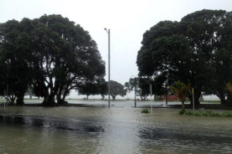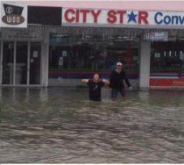
2014 Cyclone Ita – Mission Bay Selwyn Reserve & Cnr Tamaki Drv / Patteson Ave
APR Ex Cyclone Debbie Slip behind ohi Apartments

Slips on Tamaki Drive, gapipiRd and epa Rd
Road closures for weeks
Trees down across epa Road
Trees down inMadills arm seriously in uring child
Black lagged beaches unsafe to swim for
weeks
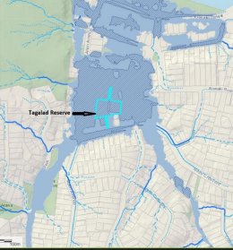 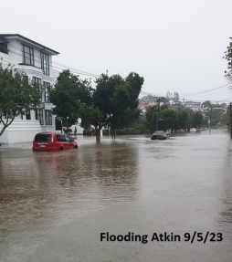Perfect spot for nature infrastructure – Tagalad reserve 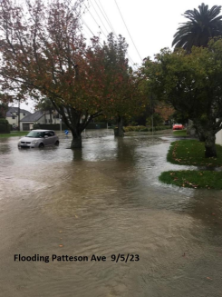 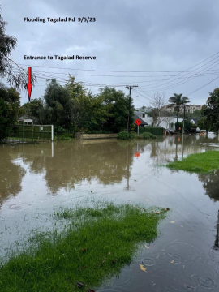
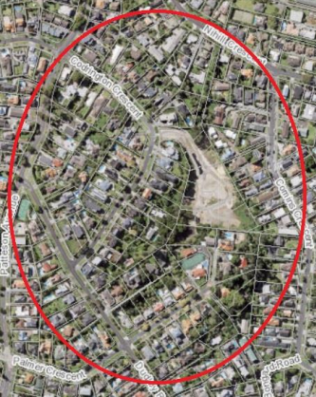 Mission Bay Urban orest SH and MHS zone
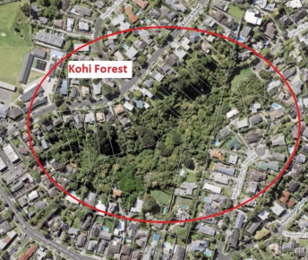 ohimarama orest

